V85X
文档下载，http://www.sochip.com.cn/v85x

ftp://sochip.com.cn
id:V85x
pass:V85x_TINA202207020927

SDK下载

http://www.sochip.com.cn/v85x/index.php?title=Downloading_the_Source

Procedure for Developers

- The client generates the public key and private key pair as follows.
客户参考下面生成公钥和密钥
- Log in web http://120.78.234.148:8099/ to register your Git lab ID
登录网站 http://120.78.234.148:8099/ 注册Git lab账号
- Email your Git lab username, company name and project name to developer@sochip.com.cn
将您的用户名，公司名，项目名称邮件发到developer@sochip.com.cn
- After Sochip administrator approval and send a confirmation email to you, you can use the ID to sign in.
收到您的邮件后，研发将授权您的账号可被使用

How to Create A Public Key Private Key Pair
如何创建公钥和密钥

Execute the following commands on the terminal (BASH).
在Bash上执行如下命令
$ ssh-keygen -t rsa

How to create Git lab account
如何创建Git lab 账号
- Log in http://120.78.234.148:8099
登录网址http://120.78.234.148:8099
- Click Register now and fill all content to register your ID
点击注册，填写完整信息注册
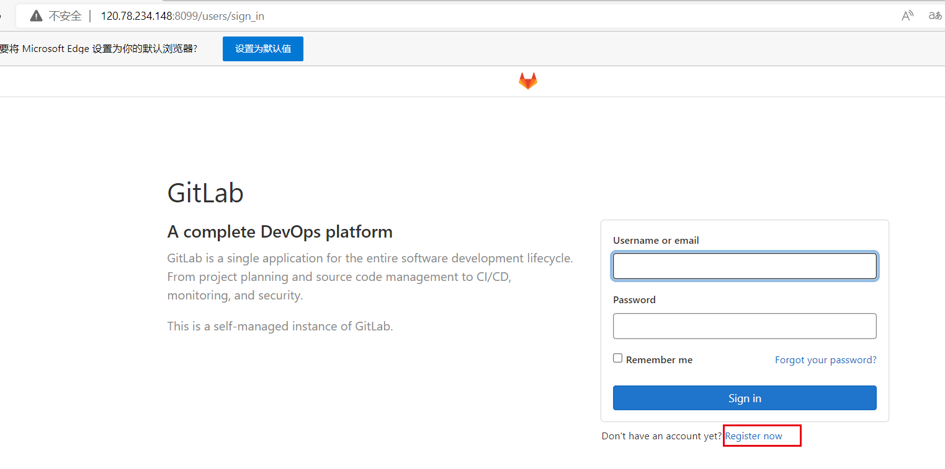
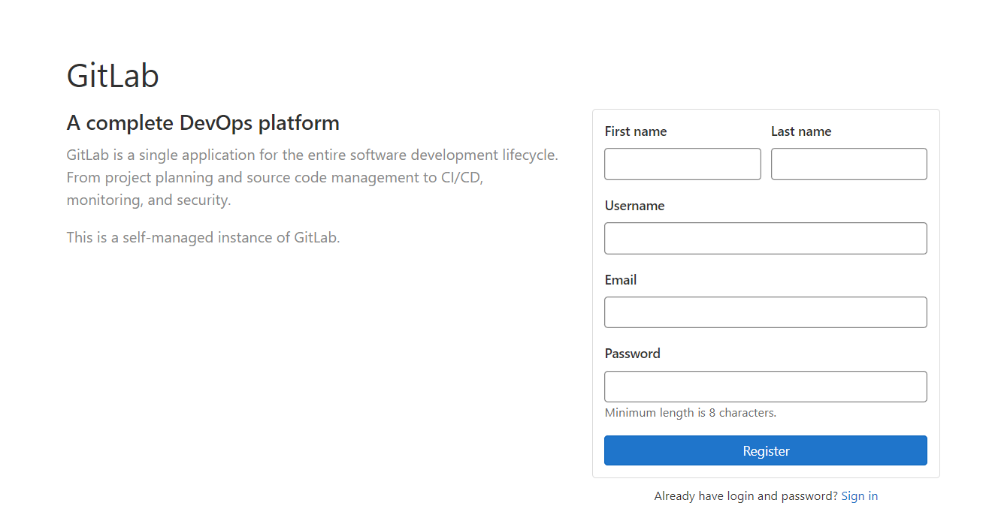

- After you finish all steps, Email your Git lab username, company name and project name to developer@sochip.com.cn, after approval you can login in, or it will shows below information when you try to sign in
完成所有步骤后，将您的用户名，公司名，项目名称邮件发到developer@sochip.com.cn ，研发将授权您的账号可被使用， 在未被授权之前登录不了会有如下提示
Your account is pending approval from your GitLab administrator and hence blocked. Please contact your GitLab administrator if you think this is an error.

How to get SSH private key
如何获取SSH密钥
- Click go to preferences 点击go to preferences

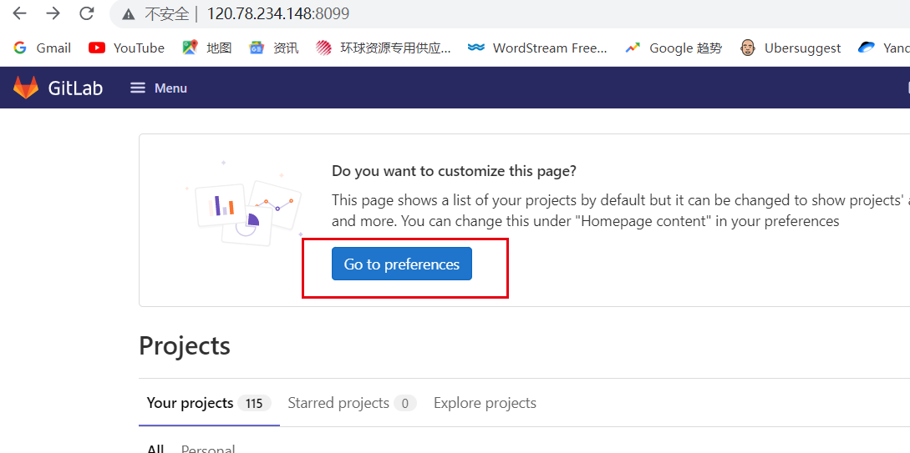
2.Click SSH KEYS 点击SSH KEYS
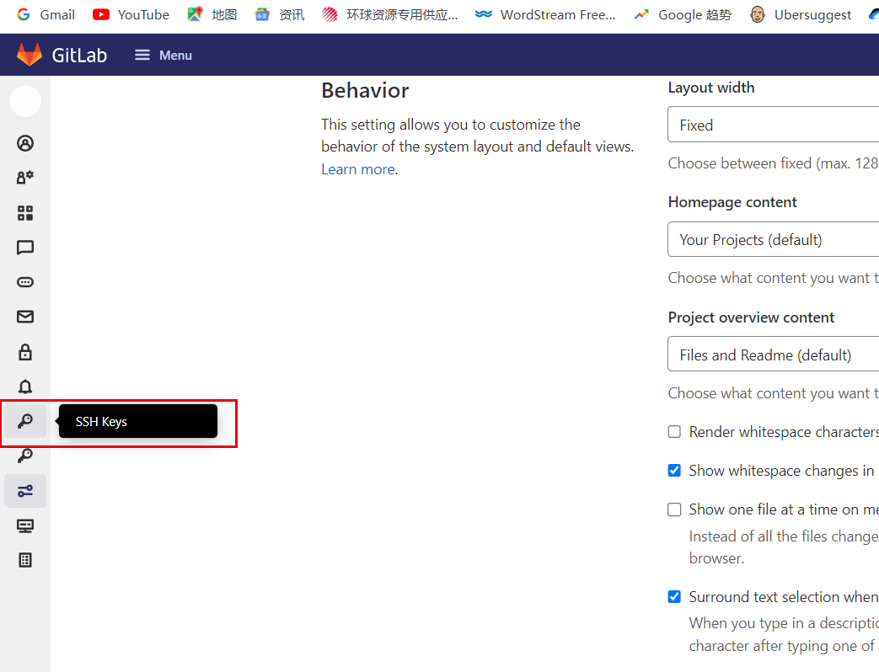

- Paste your public SSH key, which is usually contained in the file '~/.ssh/id_ed25519.pub' or '~/.ssh/id_rsa.pub' and begins with 'ssh-ed25519' or 'ssh-rsa'. Do not paste your private SSH key, as that can compromise your identity.‘
将公钥粘贴到如下框中，格式通常为'~/.ssh/id_ed25519.pub' or '~/.ssh/id_rsa.pub' and begins with 'ssh-ed25519' or 'ssh-rsa'. 点击ADD KEY （注意不要将私钥粘贴进去）
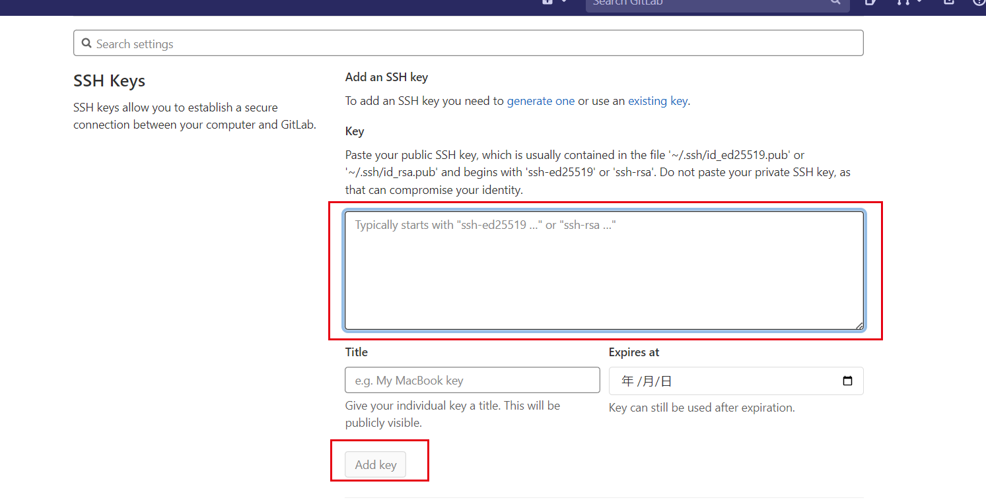

After that, you will get SSH private key like below, then you can start download SDK as follows:
之后将生成密钥
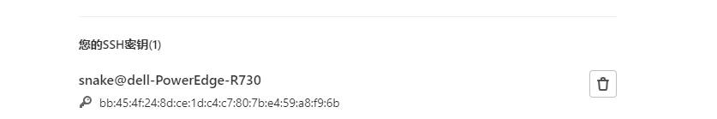

1.Installation Of Repo 安装Repo
Repo is a tool that lets you use git in a Tina environment easily and happily. Ropo是一款能让您在Tina环境轻松使用git的工具
$ git clone git@120.78.234.148:git_repo/repo.git
$ cp repo/repo /bin/repo
$ chmod a+x /bin/repo

Initialize The Repo Client 下载客户端
After installing Repo, config your client settings to access the Tina source code, and configure Git with your real name and email address. 下载Repo后，设置您的客户端来获取Tina源代码，并用您的真实姓名和电子邮件地址配置Git
$ mkdir ~/v853-sdk
$ cd ~/v853-sdk
$ git config --global user.name "Your Name"
$ git config --global user.email "you@example.com"

Download EVB SDK 下载开发板SDK
$ cd ~/v853-sdk
$ repo init -u git@120.78.234.148:v85x-sdk/manifests.git -b master -m tina-v853.xml
$ repo sync
$ repo start v853-sdk --all

V851S

